**D15B/37** **Mikil Lalwani** **IP Lab 7**

**Aim -**

Experiment to study the basics of Bootstrap.

**Theory-**

Bootstrap is a free, open-source front-end development framework for the creation of websites and web apps. Designed to enable responsive development of mobile-first websites, Bootstrap provides a collection of syntax for template designs.

Grid-

Bootstrap's grid system is responsive, and the columns will re-arrange depending on the screen size: On a big screen it might look better with the content organized in three columns, but on a small screen it would be better if the content items were stacked on top of each other.

Grid Classes

The Bootstrap grid system has four classes:

xs (for phones - screens less than 768px wide)

sm (for tablets - screens equal to or greater than 768px wide)

md (for small laptops - screens equal to or greater than 992px wide)

lg (for laptops and desktops - screens equal to or greater than 1200px wide)

The classes above can be combined to create more dynamic and flexible layouts.

Typography-

Bootstrap's global default font size is 14px, with a line height of 1.428.

This is applied to the <body> element and all paragraphs (<p>).

In addition, all <p> elements have a bottom margin that equals half their computed line-height (10px by default).

Popover-

The Popover plugin is similar to tooltips; it is a pop-up box that appears when the user clicks on an element. The difference is that the popover can contain much more content.

**Code-**

<body>

<nav class="navbar navbar-expand-lg" style="padding: 5px 40px 5px 40px; background-color:aqua;">

<div class="container-fluid">

<a class="navbar-brand" href="#">MovieTime</a>

<button class="navbar-toggler" type="button" data-bs-toggle="collapse" data-bs-target="#navbarNavDropdown"

aria-controls="navbarNavDropdown" aria-expanded="false" aria-label="Toggle navigation">

<span class="navbar-toggler-icon"></span>

</button>

<div class="collapse navbar-collapse" id="navbarNavDropdown">

<ul class="navbar-nav">

<li class="nav-item"> <a class="nav-link active" aria-current="page" href="#">Movies</a> </li>

<li class="nav-item"><a class="nav-link" href="#">Stream</a></li>

<li class="nav-item"><a class="nav-link" href="#">Events</a></li>

<li class="nav-item"><a class="nav-link" href="#">Plays</a> </li>

<li class="nav-item"><a class="nav-link" href="#">Sports</a> </li>

<li class="nav-item"><a class="nav-link" href="#">Activites</a></li>

<li class="nav-item"><a class="nav-link" href="#">Buzz</a></li>

</ul>

</div>

</div>

</nav>

<div class="container" style="margin-top: 20px;">

<h4>Recommended Movies</h4>

<div class="posters">

<div class="container text-center">

<div class="row" style="padding: 10px 0px 10px 0px;">

<div class="col-md-3" style="padding: 20px 0px 0px 0px;">

<img src="https://assets-in.bmscdn.com/discovery-catalog/events/tr:w-400,h-600,bg-CCCCCC:w-400.0,h-660.0,cm-pad_resize,bg-000000,fo-top:oi-discovery-catalog@@icons@@heart_202006300400.png,ox-24,oy-617,ow-29:ote-OTYlICAyayB2b3Rlcw%3D%3D,ots-29,otc-FFFFFF,oy-612,ox-70:q-80/et00336339-pgamkwuvva-portrait.jpg"

alt="Image" style="width: 80%; border-radius: 20px;">

<div style="padding: 15px 0px 0px 0px;">

<p>Shivpratap Garudjhep <br> Action,Drama,Historical</p>

</div>

</div>

<div class="col-sm-3" style="padding: 20px 0px 0px 0px;">

<img src="https://assets-in.bmscdn.com/discovery-catalog/events/tr:w-400,h-600,bg-CCCCCC:w-400.0,h-660.0,cm-pad_resize,bg-000000,fo-top:oi-discovery-catalog@@icons@@heart_202006300400.png,ox-24,oy-617,ow-29:ote-ODYlICA0N2sgdm90ZXM%3D,ots-29,otc-FFFFFF,oy-612,ox-70:q-80/et00319143-egauxbljnf-portrait.jpg"

alt="Vikram Vedha" style="width: 80%; border-radius: 20px;">

<div style="padding: 15px 0px 0px 0px;">

<p>Vikram Vedha<br>Action,Crime,Thriller</p>

</div>

</div>

<div class="col-sm-3" style="padding: 20px 0px 0px 0px;">

<img src="https://assets-in.bmscdn.com/discovery-catalog/events/tr:w-400,h-600,bg-CCCCCC:w-400.0,h-660.0,cm-pad_resize,bg-000000,fo-top:oi-discovery-catalog@@icons@@heart_202006300400.png,ox-24,oy-617,ow-29:ote-NzQlICAyayB2b3Rlcw%3D%3D,ots-29,otc-FFFFFF,oy-612,ox-70:q-80/et00335128-vyujcnpqvr-portrait.jpg"

alt="" style="width: 80%; border-radius:20px">

<div style="padding: 15px 0px 0px 0px;">

<p>Goodbye<br>Comedy,Drama,Family</p>

</div>

</div>

<div class="col-sm-3" style="padding: 20px 0px 0px 0px;">

<img src="https://assets-in.bmscdn.com/discovery-catalog/events/tr:w-400,h-600,bg-CCCCCC:w-400.0,h-660.0,cm-pad_resize,bg-000000,fo-top:oi-discovery-catalog@@icons@@heart_202006300400.png,ox-24,oy-617,ow-29:ote-OTElICA1OWsgdm90ZXM%3D,ots-29,otc-FFFFFF,oy-612,ox-70:q-80/et00325579-gnfcpggxrl-portrait.jpg"

alt="" style="width: 80%; border-radius:20px">

<div style="padding: 15px 0px 0px 0px;">

<p>Godfather<br>Action,Drama</p>

</div>

</div>

</div>

</div>

</div>

</div>

</body>

</html>

**Screenshots-**

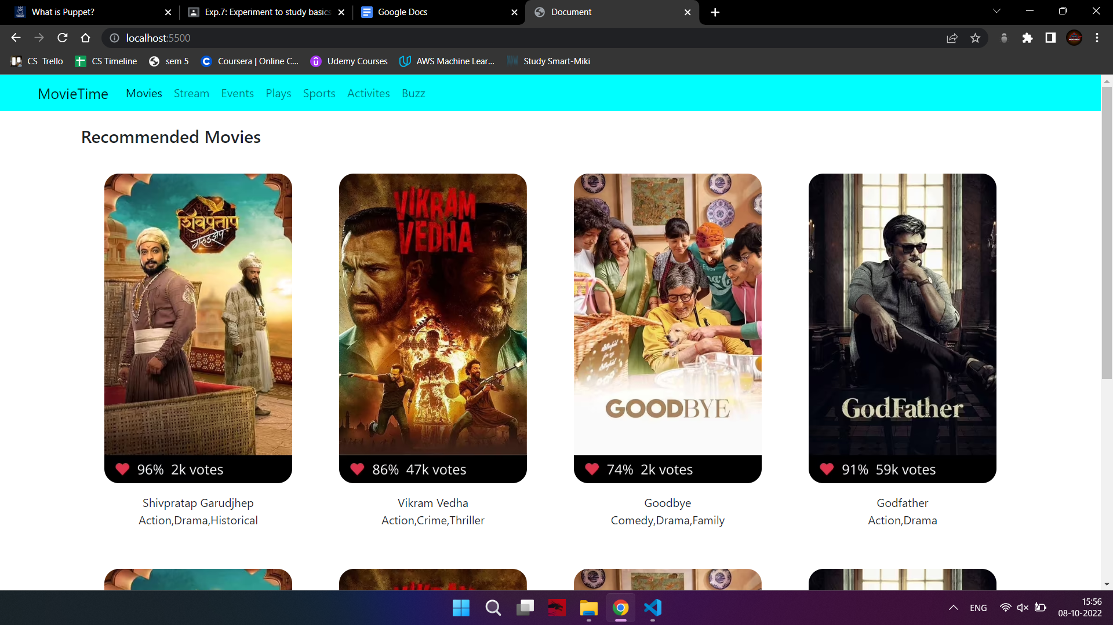

**Conclusion-**

We have successfully completed the experiment.